Tiger Strikes Asteroid New York

1329 Willoughby Ave, #2A Brooklyn, NY 11237  
(347) 746-8041

[newyork@tigerstrikesasteroid.com](mailto:newyork@tigerstrikesasteroid.com)  
www.tigerstrikesasteroid.com

***Circuladium: Rain Catcher***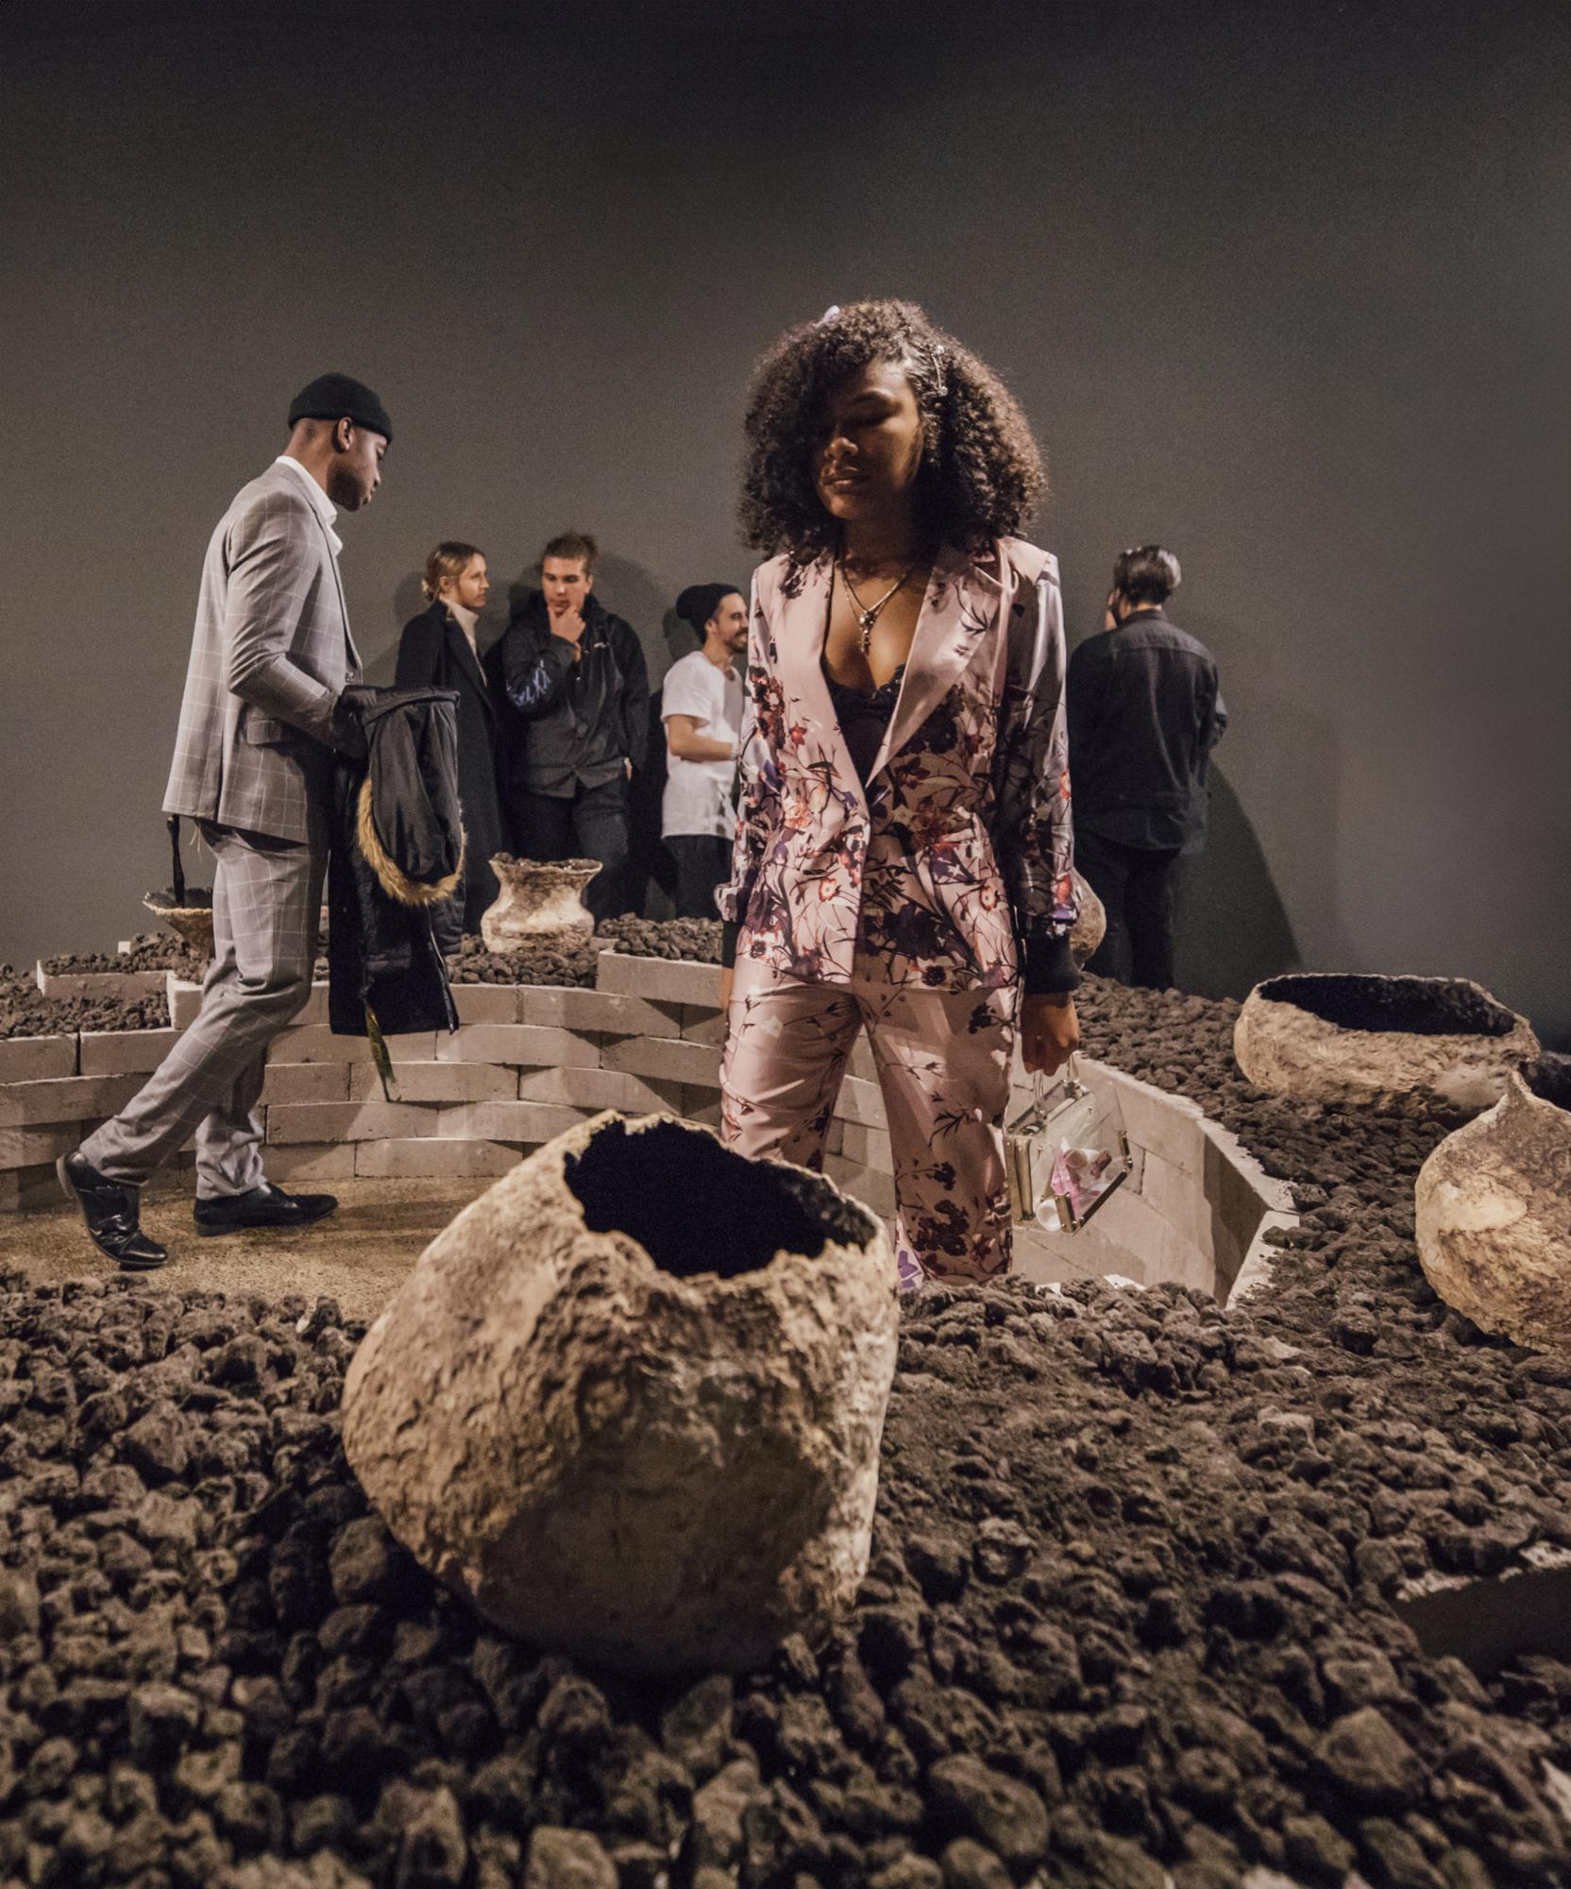

July 19 – August 17, 2024.  
  
Opening Reception:   
Saturday, July 19, 6 – 9pm   
With performance by Hui-Ying Tsai  
  
Closing reception:   
Sunday, August 17 1-6pm   
With live music performances by Jonathan Grover (Electronics), Trevor Deke Bajus (Guitar, Electronics), Mike Golub (Drums), Eric Eble (Bass), and Patricio Jijón (Electronics)

BROOKLYN, NY – Tiger Strikes Asteroid New York is pleased to present ***Rain Catcher***, the first exhibition since 2020 to focus on this collaborative project by Hui-Ying Tsai and Jonathan Grover and the recipient of our 2025 solo exhibition open call. Water, clay, seashells, sand, and morphing sound are omnipresent materials in these interactive installations that invite viewers to connect with one another across time and space.

*Southern Star*, 2025, Ceramics, mixed media, water, and custom electronics, dimensions variable. This interactive installation uses saltwater as a conductor to trigger sound when viewers touch the water. It weaves together a collection of 60 Hz waveforms, interlaced with natural sounds of water in its many forms. The resulting soundscape creates a quiet, meditative realm—subtle in presence, yet deeply resonant in effect. Photo credit: Red Bull Arts

In these works, the artists reference universal stories and phenomena experienced by many individuals throughout countless cultures. Flood and creation myths are alluded to in the piece *Southern Star*. Viewers are invited to manipulate ASMR-inducing sound by touching saltwater in the sculptures. These works, as well as *Twins*, invite us to contemplate the many facets of ourselves, others, and the networks between us. *Mother* draws viewers in by activating the wonder one experiences when hearing “the ocean” and “siren” in a conch shell, and keeps us engaged with an original lullaby of Tsai inspired by her grandmother’s singing in childhood, thus highlighting the universal qualities of personal histories. In all works, the relationship one person can feel with another individual when hearing something composed or manipulated by that individual is an enduring theme, made all the more precious by the ephemeral nature of sound.

The piece *Southern Star* is manifested by the classic elements: earth, water, fire, air – making the work timeless, as if it’s always been there. In parallel to the ever-circulating elements, the piece is activated by the viewer's impermanent presence. The artists ask us to wonder what some early human experiences might have been like, and still resonate with us today. For Circuladium, art is a means of transcendence, a celebration of existence, and a medium for personal and collective connections. By means of collective connections, ***Rain Catcher*** features a new participatory interactive piece, *Dowsing Stylus*, which explores the subconscious and non-verbal communication between people, where the viewers search inward and still meet others in a collaborative experience.

Performances will take place during the opening and closing receptions of the exhibition.

Circuladium is a new media art duo based in Brooklyn. It was formed by Hui-Ying Tsai and Jonathan Grover in 2018. Both artists gained their MFA in New Genres and Design and Technology, respectively, from the San Francisco Art Institute in 2009. When not working as a duo, they work independently on diverse subjects and media and collaborate with other artists and professionals.

Hui-Ying Tsai is an internationally active Taiwanese American interdisciplinary artist. Her public collections include the National Taiwan Museum of Fine Arts and the Taitung Art Museum. She is a fellow of MacDowell Colony, Joan Mitchell Foundation, MASS MoCA, Sculpture Space, Yingge Ceramic Museum, Anderson Ranch Arts Center, The Vermont Studio Center, The Millay Arts, Red Bull Arts Detroit, Pier-2 Arts Center, Cheng Long Wetlands International Art Project, Red Bull Arts Detroit, Guandu International Nature Art Residency, the Antenna: Spillways Residency, and Fresh Winds Biennale, Art in Country of Tokyo to name a few.

Jonathan Grover is a burgeoning new media and sound artist renowned for interactive sculptures. Grover secured an MFA grant from the San Francisco Art Institute. His artistic contributions have been featured in Creative Quarterly and The San Francisco Chronicle, alongside appearances on NBC Bay Area Arts. Presently based in Brooklyn, New York, Jonathan is dedicated to crafting distinctive sculptures and installations tailored for public engagement, thereby contributing to the dynamic landscape of contemporary art.

Together, Circuladium received the Excellent Award of 2018 Austronesian International Arts Award and the 2021 Hualien Art Award. The Taitung Museum of Art in Taiwan acquired their work in 2018, and it is permanently on display in Taitung County Cultural Affairs Bureau Library in Taiwan.